**Report**

**Name: UTSAV MORI**

**CLASS –CS”I”**

**Enrollment NO.:1810DMTCYFS03240**

ONLINE TEST SYSTEM PURPOSE:

The purpose of on-line test simulator is to take online test in an efficient manner and no time wasting for checking the paper. The main objective of on-line test simulator is to efficiently evaluate the candidate thoroughly through a fully automated system that not only saves lot of time but also gives fast results. For students they give papers according to their convenience and time and there is no need of using extra thing like paper, pen etc.

System Configuration:

**H/W System Configuration:-**

System          : I3 Processor.

Hard Disk       : 500 GB.

Monitor          : 15’’ LED

Input Devices : Keyboard, Mouse

Ram               : 4 GB

**S/W System Configuration:-**

Operating system    : Windows 7/UBUNTU.

Coding Language     : Java 1.7 , Hadoop 0.8.1

IDE                        : Eclipse

Database                : MYSQL

**DATA TABLE**

[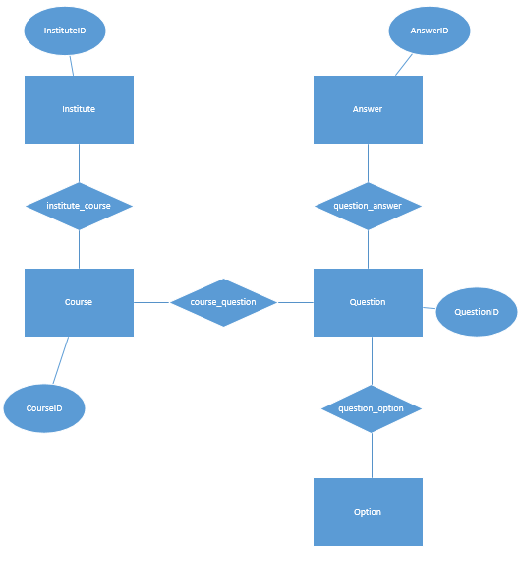](https://i.stack.imgur.com/XCnpp.png)

Conclusion

Thus **online examination management java project** report system project is developed for the Engineering student in order to view the timetable for exam and give the exam online. and This project can also focus on Generating time table for Examination and Hall Ticket generation of student who are register for examination. In this Project student can give the online exam and based on their performance the report of each student is generated. This project is a Web- based application.

In this Online Exam System Project report project we can generate hall ticket of student for examination in this hall ticket we can generate unique exam seat no. By using this student can give the online exam. And in this project we can also generate timetable for the individual department of individual classes without overlapping the date and time and this time table is generated automatically by this system. And we can also generate the seating arrangement of the student for exam Various slot combinations can be acquired so that another timetable is generated as of need. The project reduces time consumption and he pain in framing the timetable manually.